

FortnaPlus Control
DSM - Destination Status Message
Destination Status Message
Document Revision: 1.3
Date: 06-Jan-2021

Revision | Date | Author | Revision Summary
1.1 | 04-Dec-2013 | B C Conklin | Added setting up communications section
1.2 | 24-Jun-2020 | T R Kremser | Updates and general refresh
1.3 | 06-Jan-2021 | T R Kremser | Add example configuration and test plan

Table of Contents
1.1. Document Objective 4
1.2. References 4
1.3. Document Conventions 4
1.3.1. Standard Definitions 4
1.3.2. Acronyms and Abbreviations 4
2. Overview 4
3. Example One 6
Initial Setup 6
Create and Configure Full Detection Records 6
Create and Configure the Destination Area 7
Create and Configure Destinations 7
Batches Configuration 8
Machine Configuration 8
Message Map Configuration 8
Testing DSM Messages with SrtTest 9
4. Example Two 10
5. Setting up Communications 11
6. User Interface Screens 13
6.1. Destination Config table [DsmDest] 13
6.2. Destination Area Config table [DsmArea] 15
6.3. DSM Status table [DsmStatus] 18
6.4. Destination Messages Table [DsmMsg] 19
7. Testing DSM Messages with SrtTest 22
8. Test Plan Data 24

Confidential/Proprietary Statement
This document contains trade secrets and information that is considered confidential and proprietary to Fortna, Inc. It may not be duplicated, used, or disclosed outside the original recipient organization, and it may not be duplicated, in whole or in part, for any purpose other than to evaluate this document. Fortna Material Handling reserves the right to modify this document as necessary to reflect any terms and conditions negotiated and included as part of a subsequent contract or purchase order.
Introduction
This Detailed Design Document (DDD) contains the software design details for the Destination Status Message (DSM). It provides the high-level design with a system overview and sections on user interaction, system architecture, and database design. It also provides the low-level design for the data dictionary, physical database design, physical environment and class design, and an example with test plan.

Document Objective
This document describes the FPC software module for DSM messages as a vehicle for software design and to form the basis for coding and configuration.

References
These requirements were gathered through meetings and other communications methods.

Document Conventions

Standard Definitions
Destination: A section of conveyor with a presence photo eye. The photo eye is used to trigger full and clear timers. When the photo eye is blocked, the full timer is started and, when the timer completes, the destination is declared full. When the photo eye is unblocked the clear timer is started and, when the timer completes, the destination is declared empty. Also referred to as a zone.
Area: A container for the full status of multiple destinations. An area must have at least one enabled destination but could have many destinations. Area destinations are periodically checked to detect full conditions. An area is declared FULL if all enabled destinations are full, EMPTY if all enabled destinations are empty, and PARTIAL if some enabled destinations are FULL and some are EMPTY.

Acronyms and Abbreviations
DDD: Detailed Design Document.
DSM: Destination Status Message.
FPC: FortnaPlus Control.
Level 1: The FortnaPlus Machine Control System, also called FPC.
Level 2: The Warehouse Control System, also known as CommCore.

Overview
  - High-Level Summary
The goal of the DSM is to provide status updates to Level 2 concerning the Full/Clear (On/Off) status of configured areas. The status for an area can be FULL, EMPTY, or PARTIAL or alternatively, On, Off, etc. These status designation strings are customized, if desired, using the DsmStatus table. In addition to this overall area status, fields indicate the number of zones that are full, the number of zones that are empty, and comma-delimited strings list full and empty zone names.
The DSM can be configured to be sent when all zones in the area are empty, when all zones in the area are full, or when the full/clear status of any of the zones in the area change.
The processing logic uses the “Full Detection” logic to determine when a signal changes state and to filter the signal to prevent too many messages from being sent.
- The Timer_Name column of the “Full Detection” [Fullline] table defines how long the input signal must be On before a new event message is triggered.
- The Clr_Timer_Name column of the “Full Detection” [Fullline] table determines how long the signal must be Off before a new event message can be triggered.
Note: The number of destinations defined for an area, and the number of characters used for the destination name should be limited to 10. If the number of destinations exceeds 10, or if the number of characters in the destination name exceeds 10 characters, the maximum string length (approximately 100 characters) will be exceeded.
The DSM processing is controlled by the “DestArea CTRL” batch job. The batch job must be configured for each AC where it is needed using the “CTRL” process.

Example One
The following diagram shows a configuration with multiple zones in an area.
PickIn01
PickIn01Dest01
PickIn01Dest02
PickIn01Dest03
PickOut01
PickOut01Dest03
PickOut01Dest02
PickOut01Dest01
Area

Destinations
Example: Multiple destinations

Initial Setup
- Ensure that the inputs and timers listed in section 8 have been created. For convenience of testing, group photoeye bits for all destinations in an area into the same word address.
- Full/Clear timers can be auto-generated in the Fullline table as described below.

Create and Configure Full Detection Records
- Open the Fullline table (Configuration Menu -> Standard Controls -> Full Detection).
- Add a full accumulation entry for each destination. Click on the Sensor_Name field drop-down to open a popup to select the photoeye associated with the destination.
- Click on the Apply button. Click on the Save button.
- Exit FPC.
- Restart FPC.
- Open the Fullline table again. Verify that the Timer_Name and Clr_Timer_Name columns have auto-generated timers. The names will be based on the Sensor_Name field with prefix “tm” added for Timer_Name and “tmfc” for Clr_Timer_Name.
- Adjust the Timer_Preset and Clr_Timer_Preset values as desired to control the timeout period for setting the full/clear status as active.
- Click on the Save button to close the Fullline table.

Create and Configure the Destination Area
- Open the DsmArea table (Configuration Menu -> Standard Controls -> Destination Status -> DSM Area).
- Add a destination area config record for each area. Click on the Name field to add a string describing the area. Using the same name as in the HostDest field is a good choice, which must be a unique identifier.
- Click on the DsmMsgTable field drop-down to open a popup to select the message table that will be used send the DSM message. Select table DsmMsg from the list, as this table was created specifically for this message.
- Click on the HostDest field to add a string for the host destination. This is a string which will be parsed by CommCore to identify the area from which the DSM is originating. The string entered here must match the string expected by CommCore.
- Set SendNotFull if a DSM needs to be sent when all destinations becomes empty. Set SendFull if a DSM needs to be sent when all destinations become full. Set SendChange if a DSM needs to be sent when the full or clear status of any of the destinations change. Any combination of these three buttons is valid.
- Set Enabled to activate messages for the area. This is a global enable which will control sending of messages for the area, regardless of whether any of the other Send buttons are enabled and regardless of the area status.
- Click on the Apply button, then the Save button to save changes and close the table.

Create and Configure Destinations
- Open the DsmDest table (Configuration Menu -> Standard Controls -> Destination Status -> DSM Destination).
- Add a destination config record for each destination zone. Click on the Name field to add a string describing the destination.
- Click on the FullTimer field drop-down to open a popup to select the Fullline record associated with the destination.
- Click on the DsmArea field drop-down to open a popup to select the area associated with this destination. Any number of destination records can be associated with the same area.
- Click on the Enabled button to enable periodic monitoring of the full/clear status of the destination.
- Click on the Apply button, then the Save button to save changes and close the table.

Batches Configuration
- Activate the DSM processing feature in the Batches table.
- In the Process field, select the CTRL process.
- Click on the “Internal Proc CTRL” field and select “DestArea CTRL”.
- Enter 25 in the HowOften field, which will cause the “DestArea CTRL” process to run every 25th iteration of the control loop (10ms), resulting in the process running every 250 mSec. This rate can be adjusted based on the overall amount of processing done on the automation controller and the amount of latency that can be tolerated in generating the DSM messages.

Machine Configuration
- Open the Machine table (Communications Utilities… -> Machine).
- Add records for three machines with Connection_Type of TCPSERV_LISTEN, TCPSERV_RDWR, and CONNECT_TCPCLIENT. Use the SrtTest Communications_Protocol.
- Add records for three machines with Connection_Type of TCPSERV_LISTEN, TCPSERV_RDWR, and CONNECT_TCPCLIENT using the SrtComm Communications_Protocol.
- Select SERV for the Process for all six of these machines.
- Select Level 5 for LogLevel for all six machines.

Message Map Configuration
- Open the MsgMap table (Communication Utilities… -> Message Map).
- Add records for two machines. Use the Machine_Name popup to select the machines DSM_OUT and DSM_RW.
- Set the Recv_Msg_Type, Send_Msg_Type and Ack_Msg_Type fields to ALL for both machines.
- Set the MenuName field to DsmMsg.
- Set the Low_Cursor field to 1.
- Set the High_Cursor field to 20. Note that this message table is smaller than most messages.
- Set the Stat_Cursor field to 21.
- Set the Key_Cursor field to 22. Note: These cursor fields are very important. If these values are not correct, messages will be queued but will not be sent.

Testing DSM Messages with SrtTest
- Open the View I/O screen.
- Select the word address containing the photoeye bits for the destinations in an area.
- Use the “Forced On” and “Forced Off” buttons to toggle the photo eyes on and off to simulate the photo eyes being blocked and unblocked.
- Verify that the pStatus field in the DsmArea table changes from FULL to EMPTY when the full/clear timers expire.
- Verify that the pStatus field in the DsmArea table changes from FULL to PARTIAL to EMPTY when photoeye IO bits are toggled on and off.
- Verify that the AreaStatus, Zones Full and Zones Empty fields in the DsmMsg table are updated as expected when photoeye IO is toggled. If machines using the SrtTest protocol are configured, the automation controller should receive simulated message acks and the TxStat field should update to Sent. Message transactions can be reviewed by looking in the log files.

Example Two
The following diagram shows a sorter with two lanes, with a push button to indicate “Complete” at the end of each lane. The configuration described here will send a message when each push button is pressed.

PB101 - Lane 101
PB102 - Lane 102

Example: Lane push buttons
The “Configuration Menu – Full Detection” [Fullline] table is configured with an entry for each push button.
- PB101 Fullline_Timer_Name timer set to 1 millisecond, Fullline_Clr_Timer_Name timer set to 1 second (filters the push button events to not more than once per second).
- PB102 Fullline_Timer_Name timer set to 1 millisecond, Fullline_Clr_Timer_Name timer set to 1 second (filters the push button events to not more than once per second).
The “Configuration Menu – Standard Controls – Destination Status – DSM Area” [DsmArea] table is configured with an entry for each push button.
- PB101 Push Button
  - Set DsmArea_Name to “PB101”.
  - Set DSMArea_DsmMsgTable to “DsmMsg”.
  - Set DSMArea_HostDest to “PB101”.
This string will be sent to Level 2 as the Area name.
  - Activate the DSMArea_SendFull button.
- PB102 Push Button
  - Set DSMArea_Name to “PB102”.
  - Set DSMArea_DsmMsgTable to “DsmMsg”
  - Set DSMArea_HostDest to “PB102”.
This string will be sent to Level 2 as the Area name.
  - Activate the DSMArea_SendFull button.
The “Configuration Menu – Standard Controls – Destination Status – DSM Destination” [DsmDest] table is configured with an entry for each push button.
- PB101 Push Button
  - Set DsmDest_Name to “PB101”.
This string is included in the “Full List” or “Empty List” sent to Level 2.
  - Set DsmDest_FullTimer to the row from the Fullline table for PB101, created above.
  - Set DSMDest_DsmArea to the row from the DsmArea table for PB101, created above.
- PB102 Push Button
  - Set DSMDest_Name to “PB102”.
This string is included in the “Full List” or “Empty List” sent to Level 2.
  - Set DSMDest_FullTimer to the row from the Fullline table for PB102, created above.
  - Set DSMDest_DsmArea to the row from the DsmArea table for PB102, created above.

Setting up Communications
Destination Status Messages are sent from the Level 1 system to the Level 2 system. They are sent based on the configuration defined in the DsmArea table. Messages may be sent for SendNotFull, SendFull, or SendChange (send for both) events.
Each message contains the area that it is defined for in sDestination (columns Col4/Dat4), and the status for that area in sAreaStatus (columns Col5/Dat5). The default values for sAreaStatus are FULL, EMPTY or PARTIAL, as defined in the DsmStatus table. These values can be customized by entering an alternate string in the AltName column if the default strings do not make sense in a given configuration. The strings must be agreed upon with Level 2.
Example Messages:
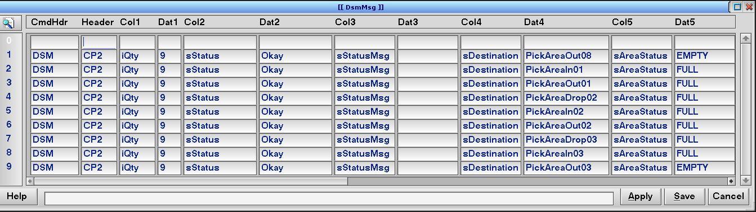
Setting up DSM messaging requires these configuration steps:
- Determine the IP of the Level 2 system.
  - Add the IP address to the file /etc/hosts with the logical name DSM_CL (to match the entry in the Machine table).
  - Example: 192.168.10.210 DSM_CL
- Add one entry to the Machine table (Configuration Menu… -> Communication Utilities… -> Machine):
  - Set Machine_Name = DSM_CL
  - Set Connection_Type = CONNECT_TCPCLIENT
  - Set Communication_Protocol = SrtCommSeq
Note: The protocol must be agreed upon with Level 2.
  - Set Machine_Port = 9001
Note: The port must be agreed upon with Level 2.
  - Set Transmit_Retry = 10 sec
  - Set Process = SERV
  - Set NeedACK = 1
  - Set LogLevel = Level 2
- Add one entry to the MsgMap table (Configuration Menu… -> Communication Utilities… -> Message Map):
  - Set Message_Name = DSMRecv
  - Set Machine_Name = DSM_CL
  - Set Recv_Msg_Type = ALL
  - Set Send_Msg_Type = ALL
  - Set Ack_Msg_Type = ALL
  - Set Menu_Name = DsmMsg
  - Set Low_Cursor = 1
  - Set High_Cursor = 20
  - Set Stat_Cursor = 21
  - Set Key_Cursor = 22

User Interface Screens

Destination Config table [DsmDest]
The DsmDest table is located under Configuration Menu… -> Standard Controls… -> Destination Status -> DSM Destination.
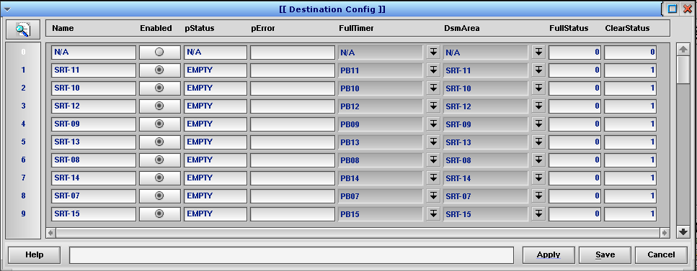
Destination Config Table [DsmDest]
FIELD | TYPE | DESCRIPTION
Name | String | Enter a unique descriptive name for the destination. This string will be added to the “Full List” or the “Empty List” depending on the state of the destination. This string must match predefined strings in Level 2. Limit the number of characters in the name to 10, with no more than 10 destinations to a group.
Enabled | Radio | Allows the user to enable or disable a configuration row. Disabled configurations will not be processed.
pStatus | String | This column is updated by the module. It indicates the full status of the Destination. Valid values are FULL or EMPTY.
pError | String | The module may display configuration error strings here.
FullTimer | PopUp | Select the row from table Fullline associated with the destination. The destination device is configured in the Fullline table to filter events using a timer. (The photo eye or pushbutton state changes will be limited based on the timer settings).
DsmArea | PopUp | Select the area associated with the destination. Any number of destinations can be associated with an area. All destinations that are enabled will be checked periodically and the full status for all enabled destinations associated with an area will be accumulated to determine the overall area status.
FullStatus | Int | This column is updated by the module and indicates if the destination is currently in a full state (0 = not full, 1 = full).
ClearStatus | Int | This column is updated by the module and indicates if the destination is currently in a clear state (0 = not clear, 1 = clear).

Destination Area Config table [DsmArea]
The DsmArea table is located under Configuration Menu -> Standard Controls -> Destination Status -> DSM Area.
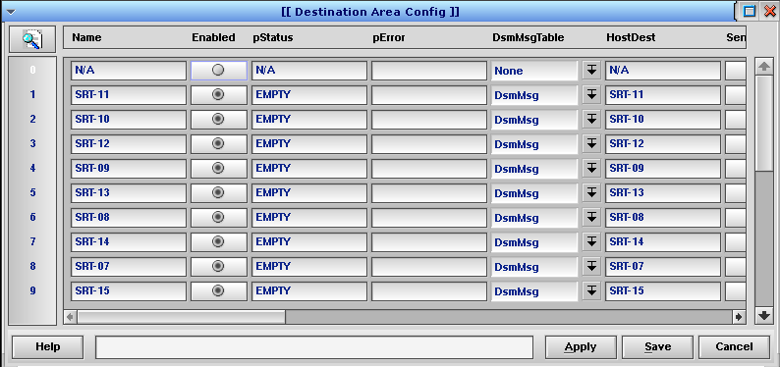
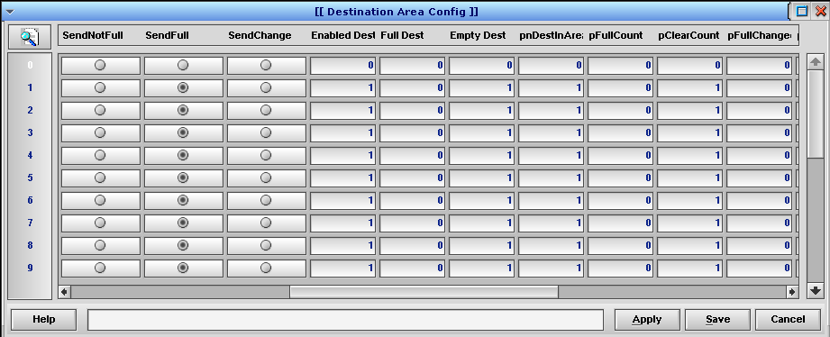
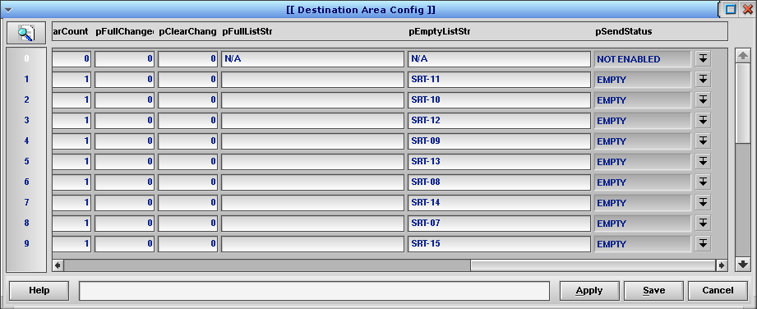
Destination Area Config Table [DsmArea]
FIELD | TYPE | DESCRIPTION
Name | String | Enter a unique descriptive name for the area.
Enabled | Radio | Allows the user to enable or disable a configuration. Disabled configurations will not be processed.
pStatus | String | This column is updated by the module. It indicates the full status of the Area. Valid values are FULL, EMPTY or PARTIAL.
pError | String | The module may display configuration error strings here.
DsmMsgTable | PopUp | Select the DsmMsg table. The DsmMsg table is designed to hold Destination Status Messages.
HostDest | String | Enter a unique identifier string to represent the area. The string is the name agreed upon with Level 2 to identify this area or zone.
SendNotFull | Radio | Enables sending a DSM when all destinations in the area are not in a full state.
SendFull | Radio | Enables sending a DSM when all destinations in the area are in a full state.
SendChange | Radio | Enables sending a DSM when the full or clear status for any of the enabled destinations changes.
EnabledDest | Int | Updated by the module to indicate the number of enabled destinations for the area. (Enabled in the DsmDest table).
FullDest | Int | Updated by the module to indicate the number of full destinations for the area.
EmptyDest | Int | Updated by the module to indicate the number of empty destinations for the area.
pnDestInArea | Int | Updated by the module to indicate the number of enabled destinations and destinations with a valid timer selected.
pFullCount | Int | Updated by the module to count the number of full destinations for the area.
pClearCount | Int | Updated by the module to count the number of clear destinations for the area.
pFullChanged | Int | Updated by the module to process the Full-Changed event. A value of 1 indicates a change has occurred, a value of 0 indicates no change.
pClearChanged | Int | Updated by the module to process the change from a Clear-Change event. A value of 1 indicates a change has occurred, a value of 0 indicates no change.
pFullListStr | String | Used by the module to create the list of full destinations.
pEmptyListStr | String | Used by the module to create the list of empty destinations.
pSendStatus | PopUp | Used by the module to hold the present state of the area. Taken from the DsmStatus table.

DSM Status table [DsmStatus]
The DsmStatus table is located under Configuration Menu -> Standard Controls -> Destination Status -> DSM Status.
The DsmStatus table is used to configure alternate names for events. If the DSM needs to indicate a FULL or EMPTY status, the AltName values do not need to be configured. If an AltName string is defined, it will be sent in place of the default string in Name. For example: If the DSM needs to indicate ON instead of FULL and OFF instead of EMPTY, the AltName values would be filled in as shown in the accompanying screen shot. Any AltName strings can be used, as appropriate, but they must be agreed-upon with Level 2.
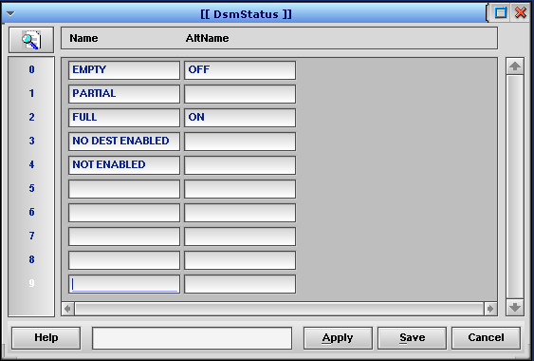

Destination Status Table [DsmStatus]
FIELD | TYPE | DESCRIPTION
Name | String | The strings in this column are the default status values. They are used to populate the sAreaStatus (Dat5) fields in a DSM. These values are populated by the module at startup.
AltName | String | The strings in this column are used to set an alternative for the sAreaStatus (Dat5) value in a DSM. If a value is set in any of the fields, it will be used in place of the default value for that condition. For example: OFF and ON can be entered to change the message content from EMPTY to OFF, and FULL to ON, as shown in the screen shot.

Destination Messages Table [DsmMsg]
The DsmMsg table is located under Configuration Menu -> Standard Controls -> Destination Status -> Destination Messages. DsmMsg is designed to hold Destination Status Messages. It follows the same format as the other message tables but is dedicated to this purpose. It has fewer columns than a “standard” message table. The messages are generated by the module. While “there are no user-serviceable parts inside”, inspecting the contents of DsmMsg can often be a helpful diagnostic tool.
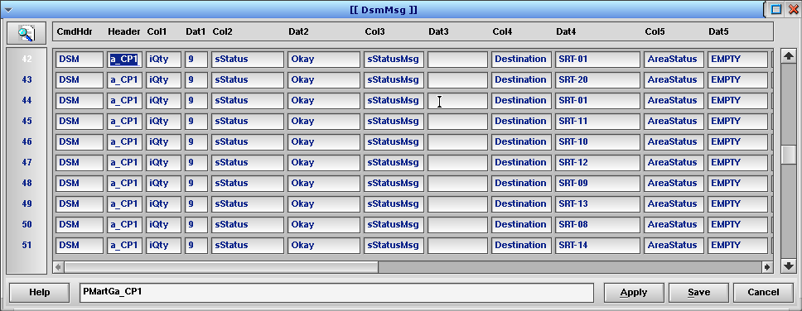
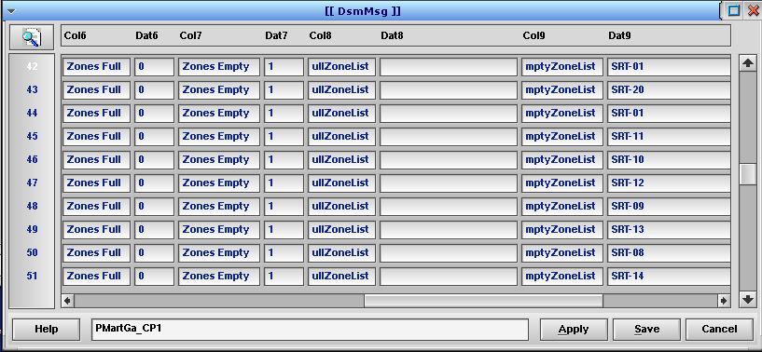
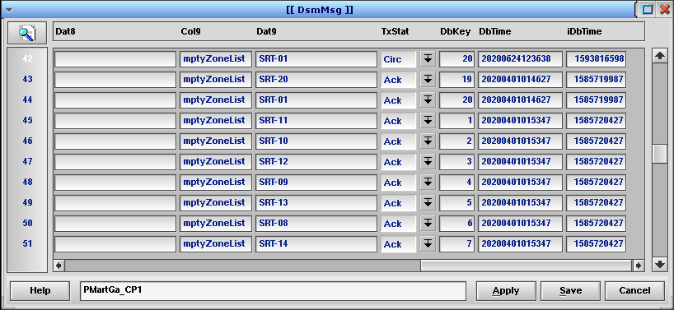
Destination Messages Table [DsmMsg]
FIELD | TYPE | DESCRIPTION
CmdHdr | String | DSM message command header. Defines the message type.
Header | String | Machine name. Indicates which machine is sending the message.
Col1 | String | “iQty” – Column name
Dat1 | String | Numeric value for “iQty”. Indicates the number of columns used in the message.
Col2 | String | “sStatus” – Column name
Dat2 | String | sStatus value – A string indicating the overall status of the message. Valid values are “Okay” and “Error”.
Col3 | String | “sStatusMsg” – Column name
Dat3 | String | sStatusMsg value – A string describing the error condition for the message, if any. This field will only have a value if sStatus = Error.
Col4 | String | “sDestination” – Column name
Dat4 | String | sDestination value – This field will contain the string from DSMArea_HostDest.
Col5 | String | “sAreaStatus” – Column name
Dat5 | String | sAreaStatus value – This string indicates the status of the area referred to by sDestination. Valid values are FULL, EMPTY, and PARTIAL, or the corresponding override values defined in DsmStatus_AltName.
Col6 | String | “Zones Full” – Column name
Dat6 | String | “Zones Full” value – A numeric string indicating the number of zones that are full in the area referred to by sDestination.
Col7 | String | “Zones Empty” – Column name
Dat7 | String | “Zones Empty” value – A numeric string indicating the number of zones that are empty in the area referred to by sDestination.
Col8 | String | “sFullZoneList” – Column name
Dat8 | String | sFullZoneList value – A comma-delimited string listing all the destination names that are currently full.
Col9 | String | “sEmptyZoneList” – Column name
Dat9 | String | sEmptyZoneList value – A comma-delimited string listing all the destination names that are currently empty.
TxStat | PopUp | Transmit Status. Used by the Automation Controller to keep track of the send status of the Message. The column indicates if the message has been sent and if Level 2 has acknowledged the message.
DbKey | Int | Database Key. Used by the Automation Controller to determine the message send sequence.
DbTime | Time | Database Time. Used by the Automation Controller to track when the message was added to the message queue.
iDbTime | Int | Database Time, Integer. Used by the software to track when the message was added to the message queue (UNIX timestamp).

Testing DSM Messages with SrtTest
- Configure a server-style connection in the Machine table in addition to the client connection defined above.
- Set Machine_Name = DSM_LS
- Set Connection_Type = TCPSERV_LISTEN
- Set Communication_Protocol = SrtTestSeq
Note: The protocol must agree with the one chosen for the client.
- Set Machine_Port = 9001
Note: The port must match the one chosen for the client.
- Set Transmit_Retry = 10 sec
- Set Process = SERV
- Set NeedACK = 0
- Set LogLevel = Level 2

- Set Machine_Name = DSM_RW
- Set Connection_Type = TCPSERV_RDWR
- Set Communication_Protocol = SrtTestSeq
Note: The protocol must agree with the one chosen for the client.
- Set Machine_Port = 9001
Note: The port must match the one chosen for the client.
- Set Transmit_Retry = 10 sec
- Set Process = SERV
- Set NeedACK = 0
- Set LogLevel = Level 2
- Configure a Batch entry for SrtServ in addition to the entry to activate the DSM processing:
  - Set File_Name = SrtServ
  - Set How Often = 1
  - Set Type = Count
  - Set Process = SERV
  - Set Internal Proc = SrtApp SERV (CPN)
  - Set Machine = <this machine>
- Open the View I/O screen.
- Select a word and bit address containing a photo eye bit for a destination in an Area.
- Use the Forced On and Forced Off buttons to toggle the photo eye ON and OFF to simulate them being blocked and unblocked.
- Verify that the pStatus field in the DsmDest table changes from FULL to EMPTY when the full/clear timer expires.
- Verify that the pStatus field in the DsmArea table changes from FULL to PARTIAL to EMPTY when photo eye bits are toggled ON and OFF to create those conditions.
- Verify that the sAreaStatus, Zones Full and Zones Empty fields in the DsmMsg table messages are updated as expected when each condition occurs.
- The SrtTest Machine connections should process the DSMs and receive simulated message acks and the TxStat field should update to “Sent”. Message transactions for both the Client and Server connections can be reviewed by looking in the SERV log file.

Test Plan Data
Data and configuration information for a test plan. These definitions correspond to the example laid out in 3. Example One.
Inputs
- PickIn1Dest1PE
- PickIn1Dest2PE
- PickIn1Dest3PE
- PickOut1Dest1PE
- PickOut1Dest2PE
- PickOut1Dest3PE
Timers
- tmPickIn1Dest1Full
- tmPickIn1Dest1Clear
- tmPickIn1Dest2Full
- tmPickIn1Dest2Clear
- tmPickIn1Dest3Full
- tmPickIn1Dest3Clear
- tmPickOut1Dest1Full
- tmPickOut1Dest1Clear
- tmPickOut1Dest2Full
- tmPickOut1Dest2Clear
- tmPickOut1Dest3Full
- tmPickOut1Dest3Clear

Fullline Table
Desc | Sensor_Name | Timer_Name | Timer_Preset | Clr_Timer_Name | Clr_Timer_Preset
PickIn1Zone1 | PickIn1Dest1PE | tmPickIn1Dest1Full | 2.00 | tmPickIn1Dest1Clear | 2.00
PickIn1Zone2 | PickIn1Dest2PE | tmPickIn1Dest2Full | 2.00 | tmPickIn1Dest2Clear | 2.00
PickIn1Zone3 | PickIn1Dest3PE | tmPickIn1Dest3Full | 2.00 | tmPickIn1Dest3Clear | 2.00
PickOut1Zone1 | PickOut1Dest1PE | tmPickOut1Dest1Full | 2.00 | tmPickOut1Dest1Clear | 2.00
PickOut1Zone2 | PickOut1Dest2PE | tmPickOut1Dest2Full | 2.00 | tmPickOut1Dest2Clear | 2.00
PickOut1Zone3 | PickOut1Dest3PE | tmPickOut1Dest3Full | 2.00 | tmPickOut1Dest3Clear | 2.00

DsmDest Table
Name | Enabled | FullTimer | DsmArea
PickIn01Dest01 | Y | PickIn1Zone1 | PickIn01
PickIn01Dest02 | Y | PickIn1Zone2 | PickIn01
PickIn01Dest03 | Y | PickIn1Zone3 | PickIn01
PickOut01Dest01 | Y | PickOut1Zone1 | PickOut01
PickOut01Dest02 | Y | PickOut1Zone2 | PickOut01
PickOut01Dest03 | Y | PickOut1Zone3 | PickOut01

DsmArea Table
Name | Enabled | DsmMsgTable | HostDest | SendNotFull | SendFull | SendChange
PickIn01 | Y | DsmMsg | PickAreaIn01 | N | N | Y
PickOut01 | Y | DsmMsg | PickAreaOut01 | N | N | Y

Machine Table
Machine_Name | Connection_type | Communication Protocol | Machine_Port | Transmit_Retry | Process | LogLevel
SRTTST_LISTEN | TCPSERV_LISTEN | SrtTest | 9200 | 2 | SERV | Level 5
SRTTST_RW | TCPSERV_RDWR | SrtTest | 9200 | 2 | SERV | Level 5
SRTTST_OUT | CONNECT_TCPCLIENT | SrtTest | 9210 | 2 | SERV | Level 5
DSM_OUT | CONNECT_TCPCLIENT | SrtComm | 9200 | 2 | SERV | Level 5
DSM_LISTEN | TCPSERV_LISTEN | SrtComm | 9210 | 2 | SERV | Level 5
DSM_RW | TCPSERV_RDWR | SrtComm | 9210 | 2 | SERV | Level 5

MsgMap Table
Message_ Name | Machine_ Name | Receive_ Msg_Type | Send_ Msg_Type | Ack_ Msg_Type | Menu_Name | Low Cursor | High Cursor | Stat Cursor | Key Cursor
DsmMsg | DSM_OUT | ALL | ALL | ALL | DsmMsg | 1 | 20 | 21 | 22
DsmTest | DSM_RW | ALL | ALL | ALL | DsmMsg | 1 | 20 | 21 | 22

Batches Table
File_Name | How Often | Increment | Type | Process | Internal  Proc | Internal  Proc Ctrl | Machine | All  Machines | Do  File
Destination Area | 25 | Invalid | Count | CTRL |  | DestArea CTRL | CP2 | N | N
SrtServ | 1 | Invalid | Count | SERV | SrtApp SERV  (CPN) |  | CP2 | N | N

